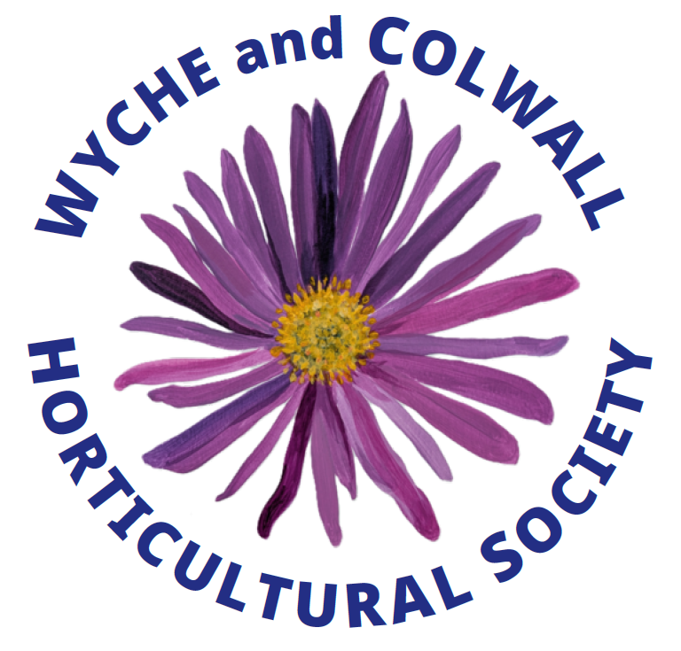 WILD about

Issue 1
August 2026 Gardening

A magazine for people who care about nature and the environment

Cover Design by pupils from Colwall Primary School

